

Proposal

## Ecommerce solution for multi-store retailers

for Leoconcept Pakistan

Feb 13th, 2018

**Table of Content**

Ecommerce solution for multi-store retailers 1

1.1 List of Figures and Tables 3

1 Introduction 4

1.1 Overview 4

1.2 Validity of offer 4

2 Statement of Work 5

2.1 Scope of Work 5

2.2 Features 6

2.3 Self-Managed Ecommerce 7

2.4 Out-of-Scope 8

## List of Figures and Tables

Figure 1 – Proposed Business Flow 4

Figure 2 – Platform Features 6

Table 3 – Ecommerce/Online Store 7

Table 4 – One Year License Renew Pricing Details 7

# Introduction

## Overview

This document describes ShopVitals’s proposal for implementation of “Ecommerce solution for multi-store retailers” use-case for Leoconcept Pakistan for their retail initiatives. The objective of this document is to provide high level implementation and costing details. This document also describes ShopVitals’s solution for the formal review requested by Leoconcept’s Pakistan for their multi-store ecommerce implementation.

There is a need of an art and science for keeping retail business intact. The ShopVitals being cloud-based software is accessible 24/7 and everywhere. It’s built-in ecommerce management platform that integrates utilities such as online store, state of art retail management, Omni channel engine, inventory synchronization, courier services, cost control, workforce management, forecasting & reconcile Cash, and beyond but all in under one umbrella, in order to simplify the online and On-premises selling lifecycle in an intuitive way for businesses. ShopVitals gives you full visibility and greater control over your business. No matter what the size of your business, we have a plan designed specifically for you. Trusted by over large businesses around the world. Here is high level proposed business flow for Leoconcept Pakistan: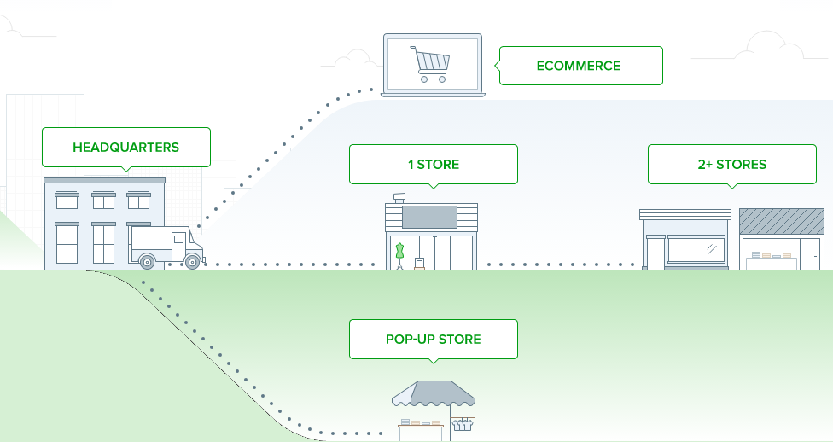

Figure 1 – Proposed Business Flow

## Validity of offer

This proposal is valid until 6th of April, 2018, on the basis of scope, dimensions and assumptions stated herein.

# Statement of Work

This Statement of Work is intended to address the scope as defined herein. Should Leoconcept request that this scope definition be changed before work commences, ShopVitals will revise and re-issue this Statement of Work, with redefined responsibilities, deliverables and associated charges. After contract signature, change requests will be handled in accordance with the Project Change Management Procedure. ShopVitals will provide a Change Authorization to the Statement of Work; when the Change Authorization has been signed off by both parties, work may commence, assuming appropriate Purchase Order cover is in place.

## Scope of Work

ShopVitals is providing implementation of ecommerce solution. ShopVitals is the web-based ecommerce system that makes it simple to sell to your customers, and keep them coming back to your store. It works on Mac or PC, online, and is so easy to use you can get your staff selling in no time. ShopVitals connects with the most popular point of sale equipment and hardware, and integrates with a variety of payment providers. With a central product catalog, you can choose what to sell in-store, online, or both. You’ll never have to manage product info and photos on multiple systems again. We’ve built ShopVitals Ecommerce so you don’t have to be a web expert to run an amazing online store.

It create custom layouts for your most popular products and speed up checkouts and quickly add products to the sale by typing in keywords or using a barcode scanner and easily find customers by name or phone number. It also allows to add notes that will appear on your customers’ receipts to let them know about care instructions, special discounts, or other targeted offers as well add discounts that will apply to all the items in a customer’s basket or to specific items only with options to choose email or print receipts after a sale. It allow customers to put their favorite items on layaway, provide partial payments, or make purchases on-account. It helps to quickly access customer payment history and current balances.

A central customer database means you can easily apply payments at another store or a later date. Keep your customers coming back by issuing store credit instead of refunds. Give every customer the flexibility to change their minds with simple refund processing and returns. Let your customers choose how they pay you. It’s no sweat to split payment types, or to accept payments from multiple parties. It reduces errors, theft and discrepancies by recording all changes from cash float to register closures. Handle cash withdrawals with ease. Get a printable record of your daily totals. Add notes about the day and check your totals by payment type

It keeps your finger on the pulse of your business by bringing all your sales, customer and inventory information together in one system. Combine your point of sale, ecommerce, and insights under one roof and save time and money. Online store is all optimized to look great on any device or screen size. Let customers buy from you even when they’re on the go thanks to store designs built with mobile phones and tablets in mind. Last but not least we provide your business facility at your Mobile phone also.

## Features



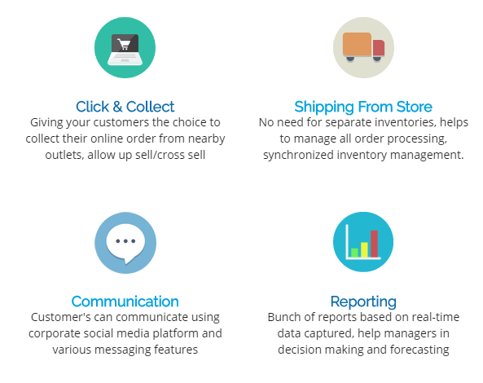

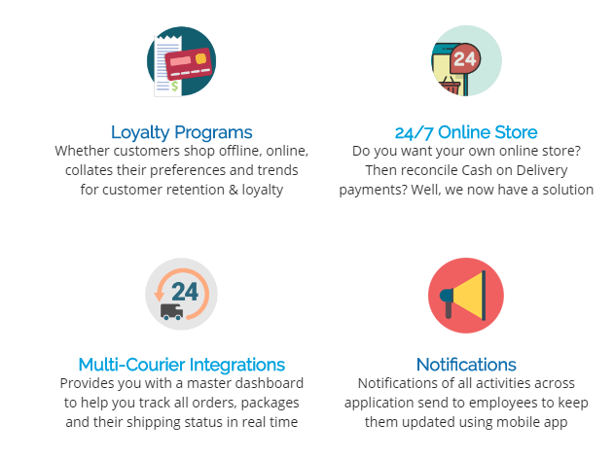

Figure 2 – Platform Features

## Self-Managed Ecommerce

* ShopVitals Integration
* Ecommerce Engine
* Uptime monitoring
* Hacking prevention
* Bug fixing
* UI/UX
* Modern Interaction Design
* Annual Online Support

| **Description** | **Qty** | **Unit Price (PKR)**  **Lifetime** | **GST/SST (%)** | **Annual Maintenance Cost (PRK)** | **Total Cost of Ownership** |
| --- | --- | --- | --- | --- | --- |
| Comprehensive Ecommerce Platform | 1 | 168,000PKR | 16% | - | 200,000PKR |
| Total Price (in PKR) | | | | | 200,000PKR |
| Conversion Rate | | | | | 0PKR |
| **Grand Total** (in PKR) | | | | | 200,000PKR |

Table 3 – Ecommerce/Online Store

| **Description** | **Qty** | **1 Year**  **Renew Contract** | **GST/SST (%)** | **Annual Maintenance Cost (PRK)** | **Total Cost of Ownership** |
| --- | --- | --- | --- | --- | --- |
| Annual License Renew | 1 | 60,000 | 16% | - | 69600PKR |

Table 4 – One Year License Renew Pricing Details

## Out-of-Scope

Following items are not part of this implementation:

1. Any enhancements to ShopVitals tool product functionality
2. Any source data migration
3. Any system integration with ShopVitals Platform
4. Any Leoconcept security and compliance policies implementation.
5. Hardware set up and procurement
6. Any end-user PC/System (OS) upgrades required by the project teams will be out of scope of implementation. Leoconcept system admin team will have the responsibility to provide Hardware and OS support. Exact specs will be provided during the design phase by ShopVitals to Leoconcept.
7. Any other statement not specified in this proposal
8. Security testing, vulnerability testing and Disaster Recovery testing
9. Translating or preparing documentation in any languages other than English.
10. Any trainings other than solution handover.